Katherine Minthorn
Northwest– OR/ID
Technical Assistance (TA) Specialist
(541) 969-4685

LEARNING TO SURVIVE
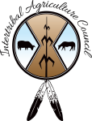

IAC Northwest Region
Confederated Tribes of Warm Springs K-8 Academy opened its doors to an estimated 675 students at the beginning of the 2014 school year. Project budget for the school was $21,472,600, the Tribes and Bureau of Indian Affairs provided 50% of the budget with the Tribes 4.6 million, and a 6.8 million loan from USDA Rural Development. Jefferson County School District 509-J provided 10.7 million through a memorandum of agreement and an Inter-agency Education Agreement between Jefferson County School District 509-J and the Confederated Tribes of Warm Springs

Mission Statement of the Warm Springs K-8 Academy are
- We believe our students should feel a sense of pride in themselves, their community and school
- We believe that the whole child is important
- We believe that all children should be loved
- We believe that pride, compassion, culture and diversity build community
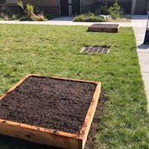
- We believe that learning is lifelong and should be nurtured

The Confederated Tribes of Warm Springs applied to the National Farm to School Network’s “Seed Change in Native Communities with Farm to School Project”. In 2017 they were awarded a mini grant which was used to implement farm to school activities in their community, and leverage community wide initiatives towards building food security and food sovereignty as well as revitalizing the use of traditional foods. The program has helped students make connections as to where food comes from and how it is part of their cultural heritage by building a greenhouse and planting a school garden and promoting a healthy snacks program, the garden has also been used for science and nutrition education. The Academy hosted an end of school year Pow wow which was attended by over 1,000 students and family members, and served a traditional dinner which included salmon, fresh foods and root vegetables.

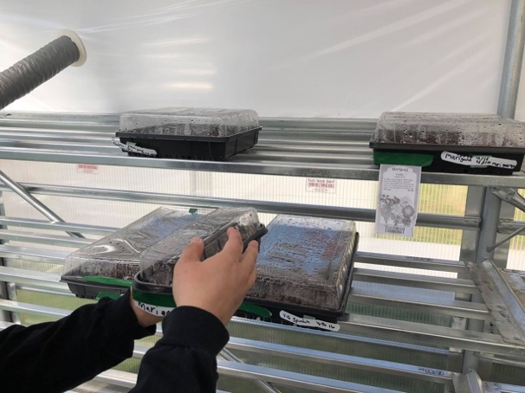

Seedlings in green

