ATTN: Indian Producers with Farm Service Agency loans
The Intertribal Agriculture Council wants to ensure maximum participation in United States Department of Agriculture (USDA) programming. The USDA was established to support those that are working tirelessly everyday to care for the land, grow food and fiber, and feed the world.

Disaster Set-Aside (DSA) Program
The Farm Service Agency (FSA) administers the Disaster Set-Aside Program during years in which an adverse weather event (or series of events) contributes to an abnormal production cycle. Disaster Set-Aside Program provides FSA borrowers, who are unable to make their scheduled annual FSA loan payment, the opportunity to request the delay of up to one full year’s payment to the end of the loan. Assistance is available in counties in which an emergency has been designated by the President, Secretary of Agriculture, or FSA Administrator.
*An example of how the disaster set aside program can influence a producer’s scheduled loan payments is included on page two.
May 21, 2020– USDA’s Farm Service Agency (FSA) broaden the use of the Disaster Set-Aside (DSA) loan provision, normally used in the wake of natural disasters, to allow farmers with USDA farm loans who are affected by COVID-19, and are determined eligible, to have their next payment set aside. In some cases, FSA may also set aside a second payment for farmers who have already had one payment set aside because of a prior designated disaster.
If would like more information or assistance in seeing how this may be beneficial to your operation, the Intertribal Agriculture Council (IAC) can provide:
- Technical assistance with the DSA application process
- Financial analysis and planning on how utilizing DSA could affect your operation
- Disaster planning assistance to help mitigate risks in the future production cycle
Reminder that FSA has Primary Loan Servicing (PLS), which is a comprehensive servicing package, is available to ALL borrowers regardless if they are in a disaster declared area or not. You are able to apply 60 days prior to payment date and not more than 90 days after payment due date. PLS package can include rescheduling debt at a lower interest rate, up to a five year payment deferment, an increased length of repayment, and/or in some cases possible reduction of debt.
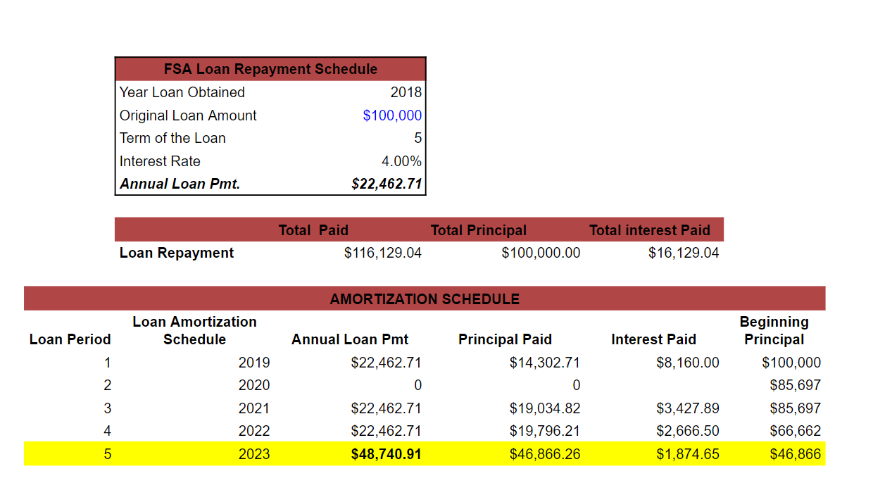
Example shows what the last payment would look like if 2020’s full payment was deferred until the end of the loan.

