Beginning Rancher from Indian County’s first steps with USDA programming:
While winter storm Wesley was hitting the Midwest with large snow amounts and continued blizzard conditions, the Intertribal Agriculture Council (IAC) proactively put together an informational write up about FSA disaster assistance focusing on the Livestock Indemnity Program (LIP) that was then posted on Facebook which reached a wide range of the population. From this post, IAC was contacted by Shorty Garrett rancher from central Cheyenne River Sioux Reservation wanting further information and assistance on LIP. IAC discovered after further discussion with him that this is a beginning rancher who was just awarded a lease agreement on a range unit from Cheyenne River Sioux Tribe. Because of this, he was also interested in what conservation programming from the Natural Resources Conservation Services (NRCS) could be of value to his operation. He had not been enrolled in any USDA programs thus far.

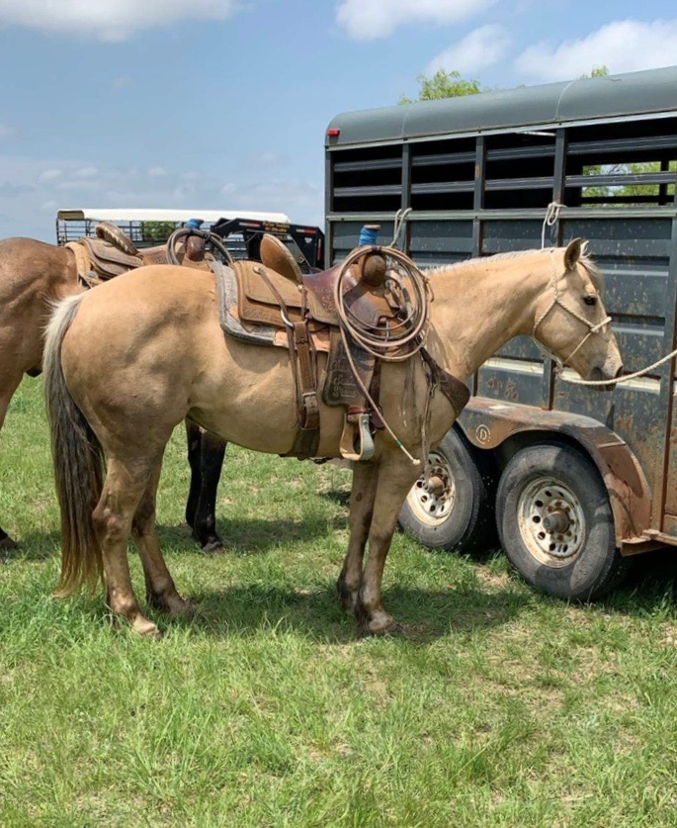
IAC conducted outreach with Garrett at his ranch headquarters. During conversation he explained how he still does things the “old cowboy way,” horseback much of the time and doesn’t have extensive cattle facilities. He has deep wooded draws in his calving pasture that are excellent protection during winter weather. But Wesley faced more than 28 inches of snow with 50 mile per hour wind causing up to 20 foot high drifts in some areas right during the heart of his calving period. Most of the death losses were not apparent until after the snow melt happened the following weeks. After this discussion, an IAC representative made sure his losses were reported to his county office and helped him fill out FSA forms for LIP, and gave him supplemental record keeping documentation.

They went on to discuss his interest in conservation programming. IAC pulled up a map of his new tribal unit going through the strengths and weaknesses of the land. Garrett expressed that pastures had excellent water sources throughout, along with a good variety of grasses, trees, and shrubs. He was given a NRCS conservation workbook that IAC went through together with him. After explaining the various programs available, he showed great interest in the Conservation Stewardship Program (CSP). He pointed out that his parents and grandparents had not utilized any NRCS programs and didn’t have much knowledge of them.

“I only knew little about NRCS programs from what I’ve been told by the neighbors at the local feed store, after meeting with IAC’s technical assistant I knew CSP was something I wanted to implement in my operation right away” Shorty Garrett

An application was filled out focusing on CSP. IAC wrote a narrative to send with the application to help NRCS better understand the producer’s operation.

This is an example of how beginning ranchers can change the existing thoughts held by many older ranchers that “none of USDA’s programs can help me, they are only for farmers.” Through IAC assistance and support, Garrett can start the right relationship with USDA. He will be able to implement conservation practices that will have long-term, positive effects. This, along with the financial benefit USDA’s programs offer, will give this beginning rancher a solid foundation that will help him have a successful and sustainable operation.

